**Robo Advisor – System Report and Documentation**

Prepared by: Chenyu Guo, Shang Shi, Eugenia Khaikhina, Yingchi Chen

**Security Selection**

Original Pool:

* International investable securities – components of MSCI ACWI and World Indices
* Canadian and US ETFs

Final Set:

* MRD.TO
* CIM.AX
* GAPSX
* LNC
* KNEBV.HE
* HBD.TO
* HGU.TO
* OIH
* RIT.TO
* EMB

Method used for selection:

We filter the assets by 1) currencies, 2) price level (exclude penny stocks) 3) volatility (exclude securities that have annualized volatilities in the top 20% of the pool of assets). After the filtering process, we deleted securities that were still missing too much data. Then we calculated annualized returns and volatilities for clustering. We clustered both the equities and ETFs into 5 clusters. From there, we try to diversify across different sectors and currencies for stocks, and holdings (eg. Energy, technology, real estates, industrials, etc.) for ETFs

**Portfolio Construction**

Goal Based Wealth Management approach is taken to portfolio construction. The portfolio is selected so that it lies on the Markowitz Efficient Frontier and the Goal Level Probability Curve (GLPC).

Inputs:

Initial Wealth, W(0): 200,000 CAD

Target Wealth, W(t): 300,000 CAD

Threshold Wealth: 100,000 CAD

Target Probability: 75%

Threshold Probability: 95%

Tenure, t: 5 years

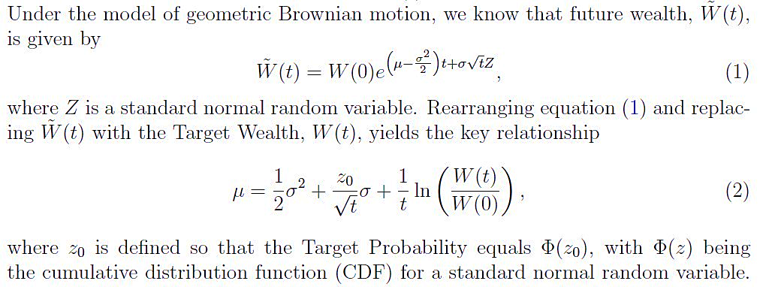

This equation defines the GLPC. Substituting the threshold wealth for the target wealth we define the Loss Threshold Curve (LTC). Ideally, our portfolio lies above the LTC.

Backtesting this portfolio construction method provided consistent result with the portfolio realized return outperforming the predicted one and realized volatility remaining within reasonable bounds from the optimized one.

|  |  |  |  |  |
| --- | --- | --- | --- | --- |
| Date Optimized | Mean Return Est | Realized Ann Return | Volatility Est | Realized Ann Vol |
| 2009-01-01 | 15.5% | 21.4$ | 18.8% | 29.9% |
| 2010-01-01 | 14.4% | 13% | 16.8% | 15.9% |
| 2011-01-01 | 14.6% | 2.4% | 16.8% | 13% |
| 2012-01-01 | 15.9% | 28.3% | 19.5% | 12.9% |
| 2013-01-01 | 14.6% | 25.8% | 16.8% | 11.3% |

**Risk Model**

**Risk Factors for different asset classes**

We selected our equity universe to consist equities in different countries including CAD, AUD, EUR, JPY, USD. For each country’s equity, we are using Fama-French 5 factors issued in each country and the fx exchange rate between it’s currency and USD as the risk factor. For ETF:fixed income and the index of Dow Jones average industry index we are choosing the following factors:

|  |
| --- |
| **ticker** |
| SP500 |
| US Large Cap |
| US Small Cap |
| US Mid Cap |
| TSX |
| Europe |
| EM |
| US/CAD |
| US Treasury |
| US Corp High Yield |
| US IG 5-10 yr |
| CGOV 10y |
| CGOV 5y |
| CGOV 2y |
| Gold |
| Crude Oil |
| US Real Estate |
| CAN Real Estate |
| Toronto Real Estate |
| VIX |

Then for implied volatility, we are using 5 US Fama-French 5 factor model and VIX as the risk factors.

**Backtesting**

Here we showed the prediction power on 90 days return based on 5 year’s historical data.

**ETF: fixed income**

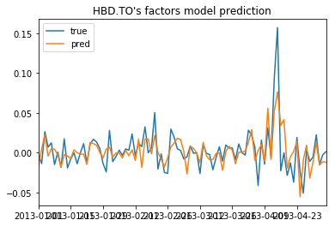

**Index:**

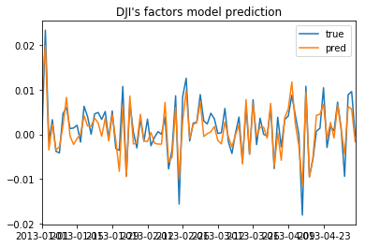

**Implied vol:**

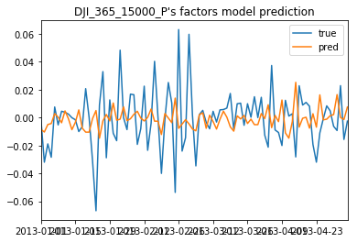

**Equity:CAD**

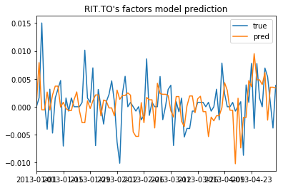

**Equity:USD**

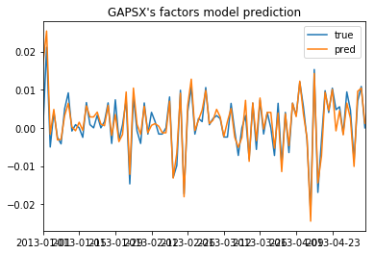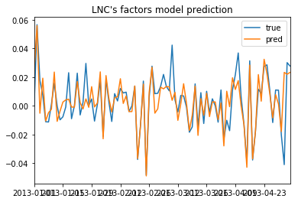

**Equity:EUR**

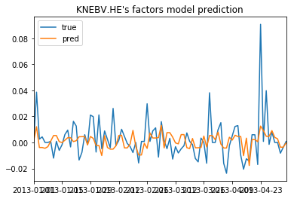

**VaR Back Test:**

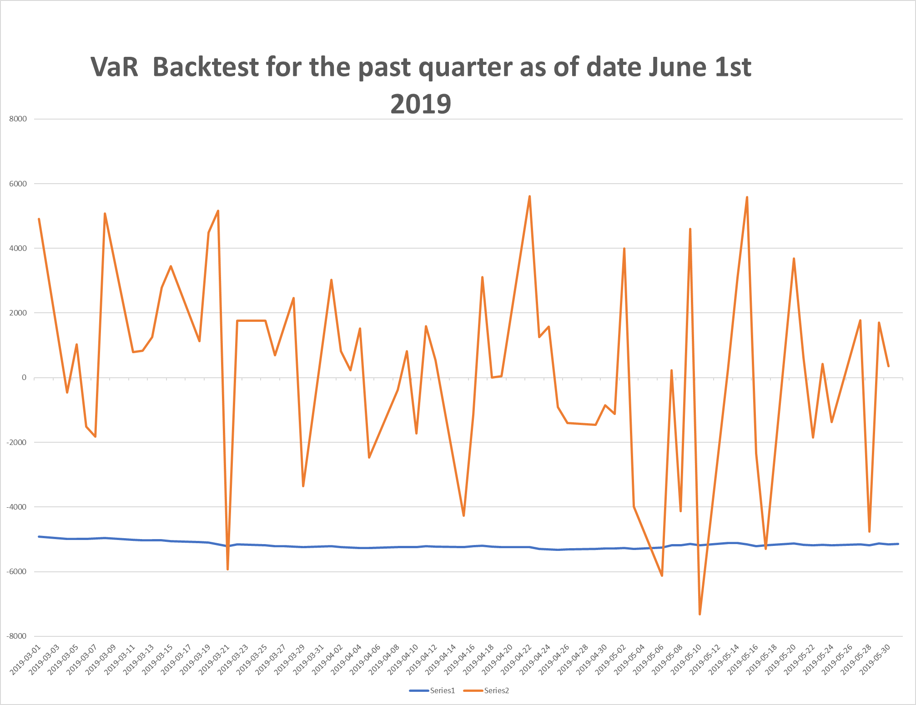To validate our model, we did backtesting on Value at Risk for performance period 2014-04-01 to 2019-06-01. First, we compute the daily Value at Risk from factor model, with data from the past five years. Then we compute the daily P&L. The backtesting results are presented below.

From the plot above, we see that our p&l breaks the 95% VaR for the past month 4 times out of the 66 forecasts.

**Performance Analytics**

Simple returns are computed on the security and portfolio levels. Also, the Time-weighted and Money-weighted returns are compared.

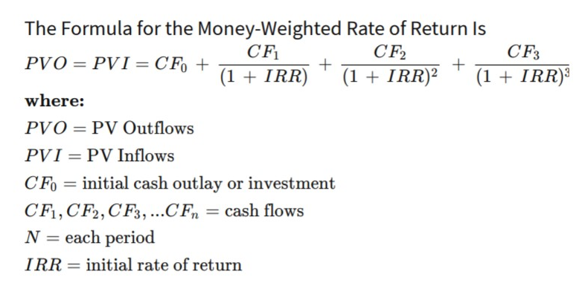

Formula for the Time-Weighted Return is

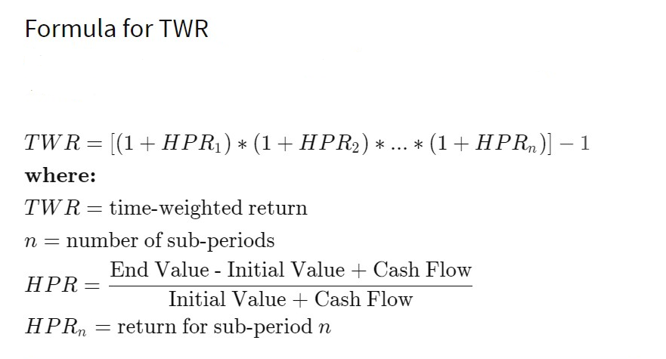

Performance is attributed to each individual security return in local currency and the corresponding FX appreciation rates.

Each individual asset return r­i is said to be equal to:

*ri=li+ei+l­i e­­i*

Here li is the return in local currency and ei – FX appreciation effect

These are weighted to arrive at aggregate contributions at the portfolio level.

**Scenario Analysis**

Risk Factors are assumed to follow a multivariate normal distribution. This allows us to easily compute conditional distributions for some factors given fixed returns of the others.

We want to show what would the impact on our portfolio if the two major historic crises were to happen again today: the Asian Crisis and the Financial Crisis.

Inputs:

Main market factor monthly returns during 24 months around the bottom of the crises as defined by the US Market factor lowest point.

Next the conditional means are computed using the following formulas:

